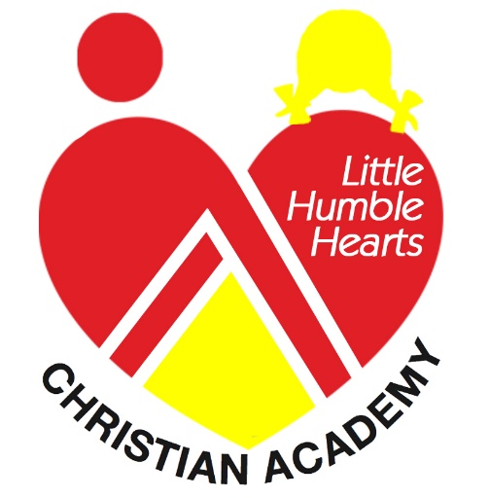

Little Humble Hearts Christian Academy
114 South Chester Avenue/ P. O. Box 178
Ruleville, MS 38771
Phone: (662) 878-5008/ (662) 878-9832
Email: lhhcacademy@yahoo.com
Website: www.lhhcacademy.com

COVID-19 Release and Waiver
I, _______________________________________ as parent and legal guardian, hereby acknowledge the health risks and dangers associated with the transmission of the COVID-19 virus, and other communicable diseases, and recognize that exposure to the COVID-19 virus, or other communicable diseases, could occur while my child is in the care of Little Humble Hearts Christian Academy or the child is not attending Little Humble Hearts Christian Academy.

As such, and in consideration for childcare services to be provided by Little Humble Hearts Christian Academy, for myself and my minor child (ren) enrolled in the facility fully assumes and understands all of the risks associated with participations in the LHHCA, including the possibility of COVID-19 (Coronavirus) community spread.

I, ___________________________, as parent and/or legal guardian, have read and fully understand and acknowledge the contents of the release and agree that I am voluntarily waiving, releasing, indemnifying and discharging Little Humble Hearts Christian Academy of Ruleville MS and its Directors, employees, and volunteers from any liability, damages, and each and every action by participation in and/or associated with the facility including, but not limited to exposure or transmission of the COVID-19 VIRUS.

My signature below is confirmation that I have read and fully understand and acknowledge the contents of the release and agree that I am voluntarily waiving, and discharging Little Humble Hearts Christian Academy of Ruleville, MS and its directors, employees and volunteers from the possibility of my child(ren) contracting COVID-19 (Coronavirus) community spread.

__________________________ __________________
Parent/Guardian Signature Date

Child(ren) Names:
____________________________ _________________________
____________________________ _________________________
____________________________ __________________________
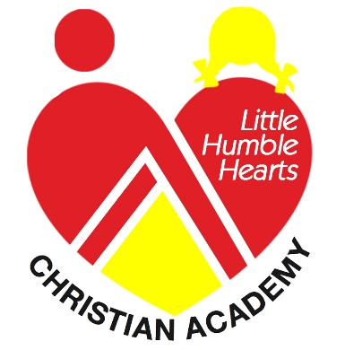
Little Humble Hearts Christian Academy
Parent or Guardian COVID-19 Handbook Receipt Form

Parents or Guardians,

Please thoroughly review the Parent Handbook “COVID-19” for the 2020-2021 school year, which contains the policies and procedures for Little Humble Hearts Christian Academy while in the process of reopening. After reading the handbook, please complete this form and return it to the school by mail or drop off at the center as soon as possible. This form will be kept in your child’s file for the duration of the school year.

Thank you for your cooperation.

Sincerely,
Okema White, CD, CDA
Director
Little Humble Hearts Christian Academy

----------------------------------------------------------------------------------------------------

I, _________________________ ( print your name) hereby acknowledge receipt of Little Humble Hearts Christian Academy Parent Handbook COVID-19, I have read and agree to adhere to all the policies and regulations set forth in this handbook.

Parent/Guardian Signature:_____________________________ Date: _________

